Heart Disease Analysis Using Data
Analytics

Created By
Y Divya 228X1A42H5
Y Bhavani Sanakar 228X1A42E8
SK Khadar Basha 228X1A42G7
M Rama Sain 228X1A42G1

INDEX

- Introduction
- Overview of the Project
- Purpose
- Problem Objective
- Project Flow
- Dataset Description
- Data Understanding and Preparation
- Tools and Technologies Used
- Data Visualization and Analysis
- Results and Discussion
- Applications
- Advantages and Disadvantages
- Conclusion
- Future Scope
- References

Heart Disease Analysis Using Data Analytics

INTRODUCTION

Heart disease is one of the leading causes of death worldwide and remains a major public health concern. In recent years, the use of data analytics in healthcare has gained significant importance in understanding, predicting, and preventing heart-related conditions. While medical treatments and diagnostic equipment play an essential role, effective healthcare today depends heavily on accurate data collection, secure storage, and meaningful analysis.

Modern healthcare systems combine patient medical records, laboratory results, ECG reports, blood pressure readings, cholesterol levels, and other clinical data. This data is stored in databases or cloud platforms and then processed using analytical tools. By analyzing this data, healthcare professionals can identify patterns, detect risk factors, and make informed decisions regarding diagnosis and treatment.

The process followed in this project begins with collecting heart disease data from reliable sources. The data is then stored and prepared for analysis by cleaning and organizing it properly. After that, the dataset is connected to data visualization tools such as Tableau to create dashboards and charts. These visualizations help in understanding relationships between different health parameters like age, cholesterol, blood pressure, and heart disease occurrence. Finally, the analyzed results are presented to users in an easy-to-understand dashboard format, which supports better decision-making.

Through this structured data analytics process—data collection, storage, analysis, visualization, and presentation—valuable insights can be generated to support early detection and prevention of heart disease.

TECHNICAL ARCHITECTURE

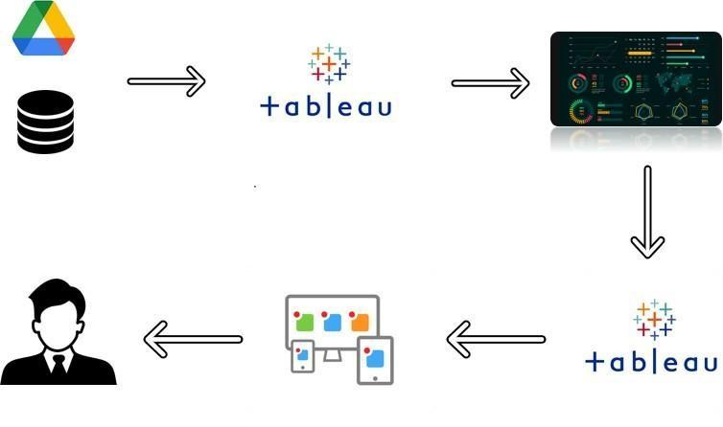

2. OVERVIEW OF THE PROJECT

This report presents the analysis of heart disease data using data analytics techniques. The study focuses on identifying important health risk factors, understanding patient characteristics, and analyzing patterns related to heart disease. The aim of this analysis is to gain better insights into how different medical parameters contribute to heart disease and how data visualization can help in early detection and prevention.

A basic healthcare data analysis is also performed to understand the major factors influencing heart disease, such as age, blood pressure, cholesterol levels, blood sugar, and other clinical attributes. This helps in identifying trends, risk categories, and important relationships within the dataset.

3. PURPOSE
The main purpose of this project is to analyze heart disease data using data analytics tools in order to improve understanding of risk factors and disease patterns.

Before performing detailed analysis, an initial data exploration is carried out to study the dataset structure, attributes, and overall data quality. The analysis is conducted with the objective of generating meaningful insights that can support healthcare professionals in making informed decisions regarding early diagnosis and prevention of heart disease.

4. PROJECT OBJECTIVES

The main objectives of this project are as follows:

i. To analyze patient health parameters such as age, cholesterol, blood pressure, heart rate, and blood sugar. ii. To study the relationship between different medical factors and the occurrence of heart disease. iii. To identify high-risk patient groups based on clinical data. iv. To develop interactive dashboards and visualizations using Tableau.
v. To support better healthcare decision-making through visual analytics.

5. PROJECT FLOW

The project follows a systematic and structured workflow, starting from data collection and ending with dashboard presentation.

Initially, the heart disease dataset was collected from reliable sources. The dataset was examined to understand its structure, attributes, and data quality.

After that, data cleaning and preprocessing were performed to remove errors, handle missing values, and organize the data properly. The cleaned dataset was then imported into Tableau Desktop for analysis.

Based on defined analytical questions, various visualizations were created. Finally, interactive dashboards were developed to clearly present insights and findings related to heart disease risk factors and patterns.

6. DATASET DESCRIPTION

In this project, a heart disease dataset was used to perform comprehensive analysis of various health parameters related to cardiovascular conditions.

The dataset includes patient information such as age, gender, chest pain type, blood pressure, cholesterol levels, blood sugar, ECG results, heart rate, and other clinical measurements. It also contains a target variable indicating the presence or absence of heart disease.

This dataset helps in analyzing risk factors, identifying patterns, and understanding the relationship between medical attributes and heart disease occurrence.

7. DATA UNDERSTANDING AND PREPARATION

Understanding the dataset is an important step in the analytics process. The data was examined to identify data types, missing values, duplicates, and inconsistencies.

Data preprocessing included handling missing values, correcting data formats, and ensuring consistency across all attributes. The cleaned dataset ensured accurate and reliable analysis for visualization and interpretation.

8. TOOLS AND TECHNOLOGIES USED

The project utilized various tools for data analysis and visualization.

Tableau Desktop was used to create charts, visualizations, and interactive dashboards. Tableau Public was used for publishing and sharing dashboards.

The dataset was stored in CSV format for easy access and processing. Microsoft Word was used for documentation of the project.

9. Data Visualization and Analysis

Heart Disease Analysis Dashboard

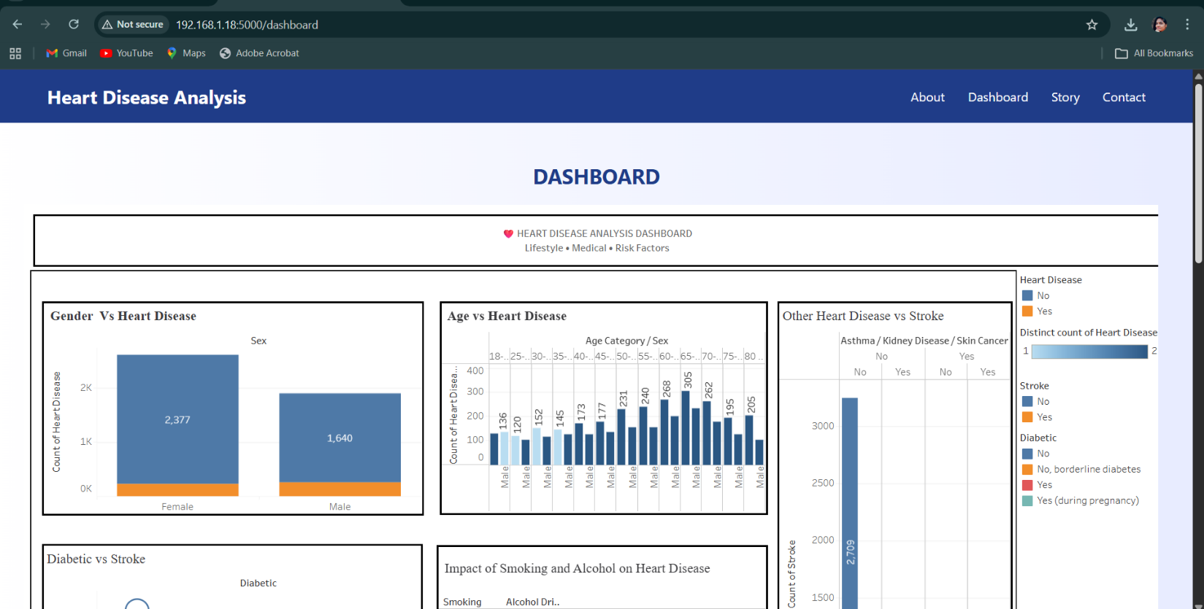
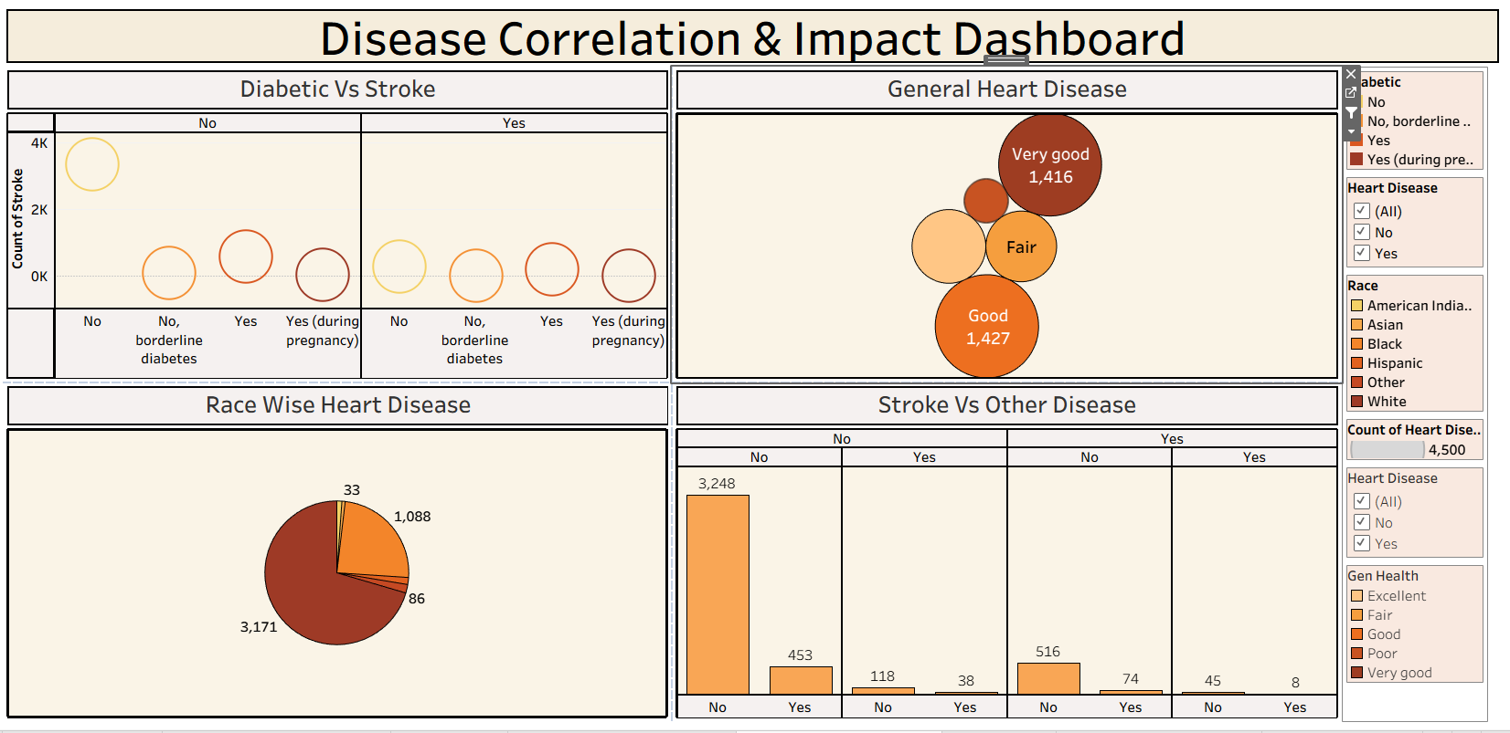

The Heart Disease Analysis Dashboard provides a visual summary of heart disease data using interactive charts.

It shows the comparison of heart disease cases by gender and age group, highlighting that risk increases with age. The dashboard also presents the relationship between heart disease and other conditions such as stroke and diabetes. Additionally, it analyzes the impact of lifestyle factors like smoking and alcohol consumption on heart disease.

Overall, the dashboard helps in identifying key risk factors and supports better understanding of heart disease patterns.

Data Visualization and Analysis

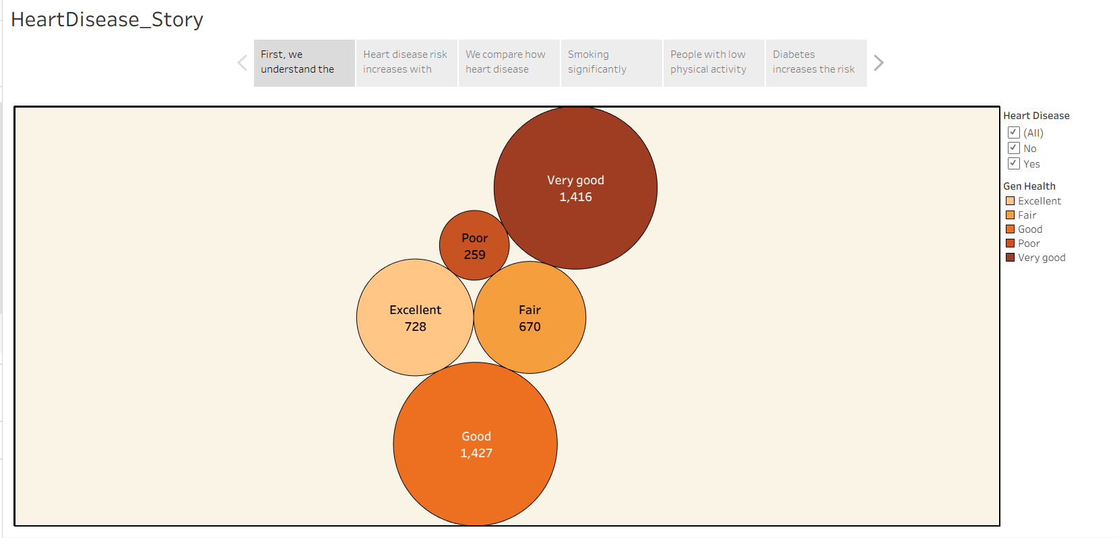

Figure 1: General Health Status and Heart Disease Distribution
Insight: The chart shows heart disease distribution based on general health condition. Most individuals fall under “Good” and “Very Good” categories, while fewer are in the “Poor” category, helping identify health-related risk patterns.
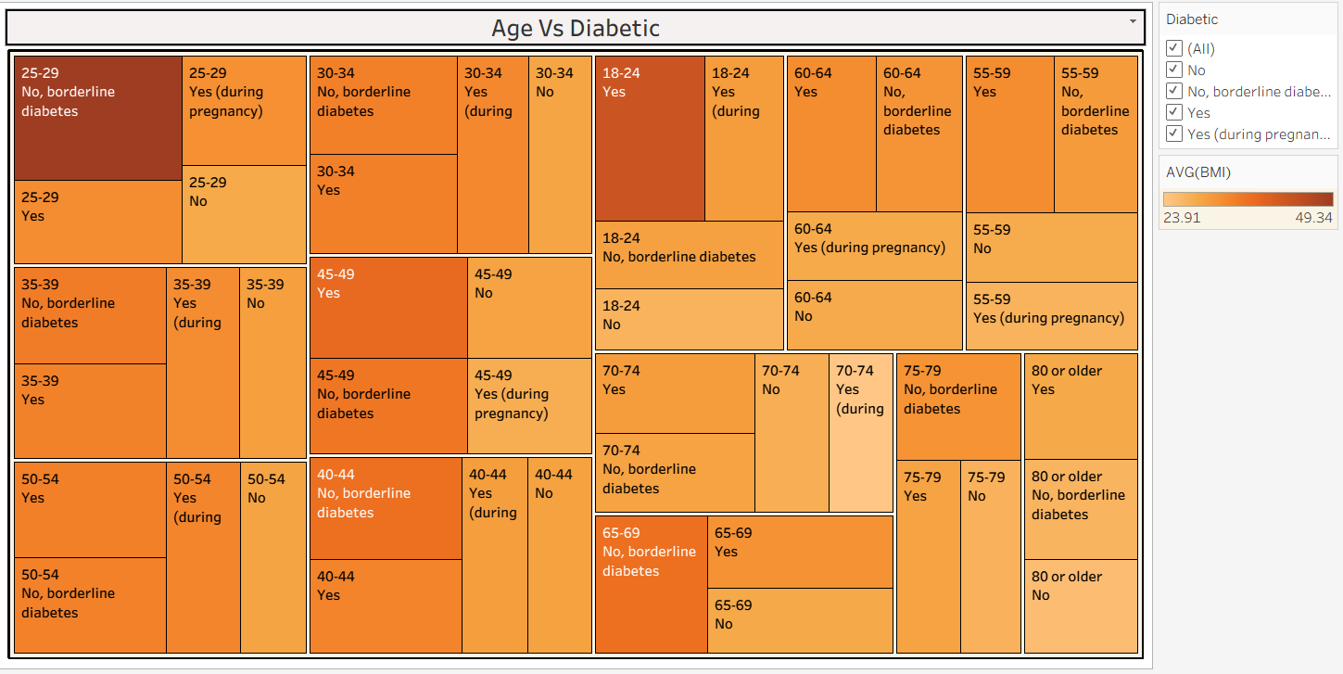

Figure 2: Combined Analysis of Age and Heart Disease
Insight: The chart shows heart disease cases across different age groups. The number of cases increases with age, especially among middle-aged and older individuals, indicating higher risk in advanced age groups.

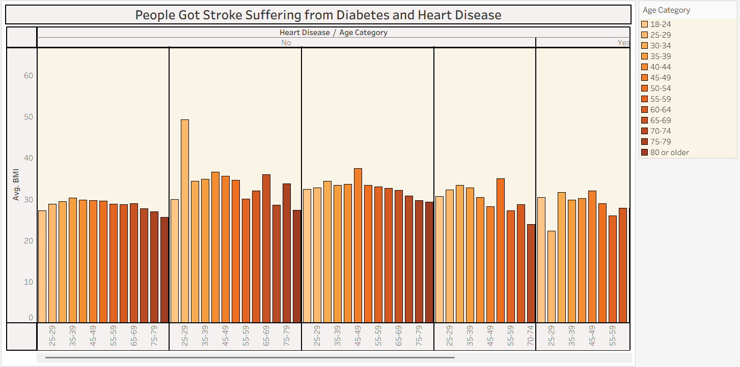
Figure 3: Stroke Occurrence Among Heart

APPLICATIONS

- Hospitals and Clinics

- Diagnostic Centers

- Healthcare Research

- Medical Data Analysis

- Preventive Healthcare Programs

- Health Monitoring Systems

- Public Health Management

ADVANTAGES

- Early Detection: Helps in identifying heart disease risk at an early stage.

- Better Decision Making: Supports doctors with data-driven insights.

- Clear Visualization: Dashboards make complex medical data easy to understand.

- Risk Factor Identification: Helps in recognizing key factors like age, cholesterol, and blood pressure.

- Time Efficient: Quick analysis of large patient datasets.

- Preventive Healthcare Support: Assists in planning preventive measures.

DISADVANTAGES

- Data Dependency: Accuracy depends on the quality of the dataset.

- Missing or Incomplete Data: Can affect analysis results.

- Limited Real-Time Data: May not include live patient monitoring data.

- Privacy Concerns: Patient data must be handled securely.

- Requires Technical Knowledge: Tools like Tableau require basic analytical skills.

- Model Limitations: Analysis results depend on assumptions and selected parameters.

ADVANTAGES AND DISADVANTAGES

Heart disease data analytics offers several advantages such as early risk detection, better medical decision-making, clear visualization of complex health data, and identification of major risk factors like age, cholesterol, and blood pressure. However, the effectiveness of analysis depends on data quality, availability of accurate records, and proper handling of patient privacy. Incomplete or inconsistent data may affect the reliability of results.

CONCLUSION

Heart disease remains one of the leading causes of death worldwide. Through data analytics and visualization techniques, it is possible to identify important risk factors and patterns associated with heart disease. The use of tools like Tableau helps in presenting complex medical data in a simple and understandable format.

Although healthcare systems must overcome challenges such as data privacy concerns and data quality issues, data-driven approaches will play a major role in improving early detection, prevention, and treatment of heart disease in the future.

FUTURE SCOPE

The future scope of heart disease analysis using data analytics is very promising. With advancements in technology, real-time health monitoring through wearable devices and electronic health records can further improve predictive analysis.

Integration of machine learning and artificial intelligence can enhance the accuracy of heart disease prediction models. In the future, healthcare systems may rely more on automated analytics tools to provide personalized treatment recommendations and preventive care strategies.

As healthcare data continues to grow, advanced analytics will become an essential part of improving public health management and reducing heart-related mortality rates.
Web Integration:

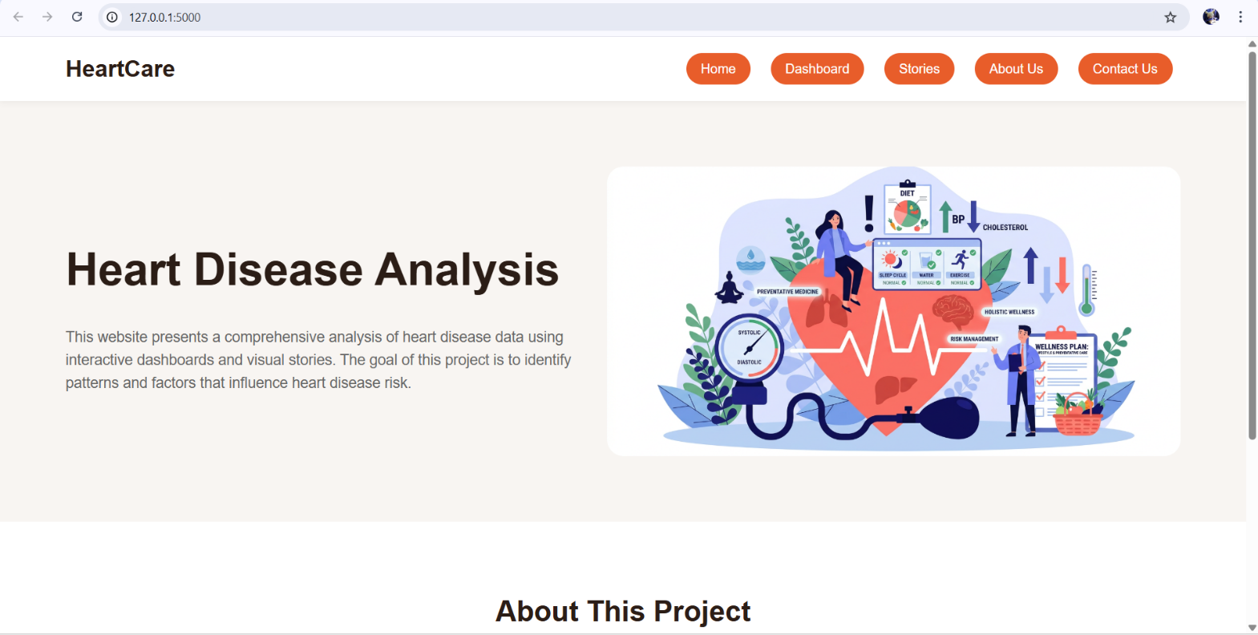

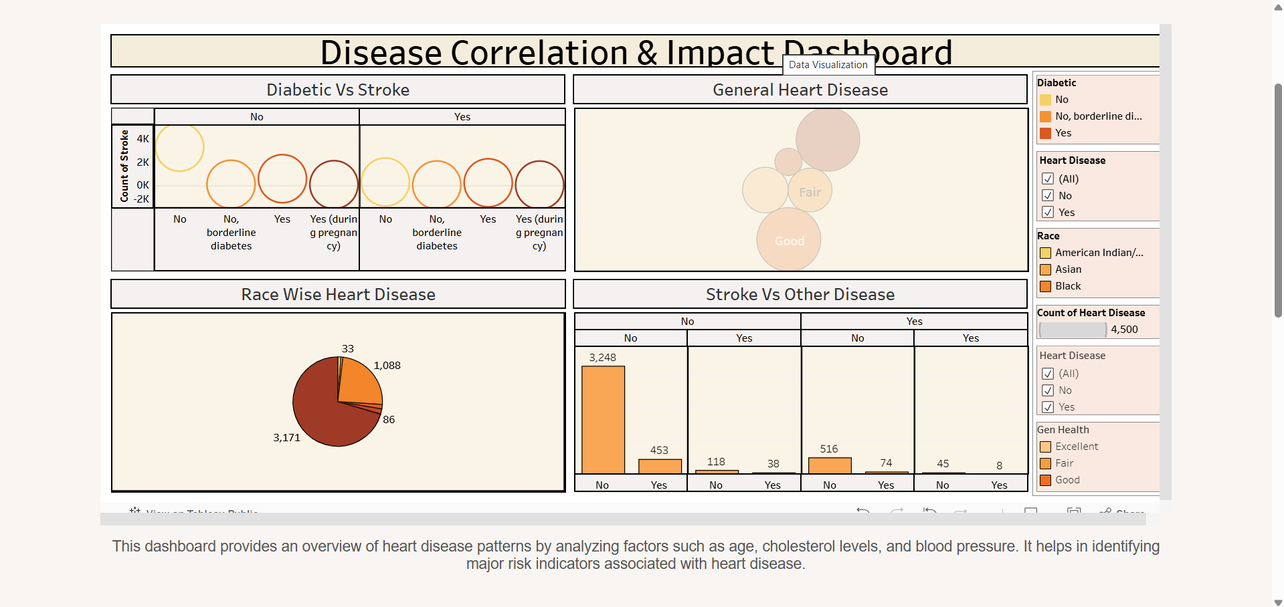

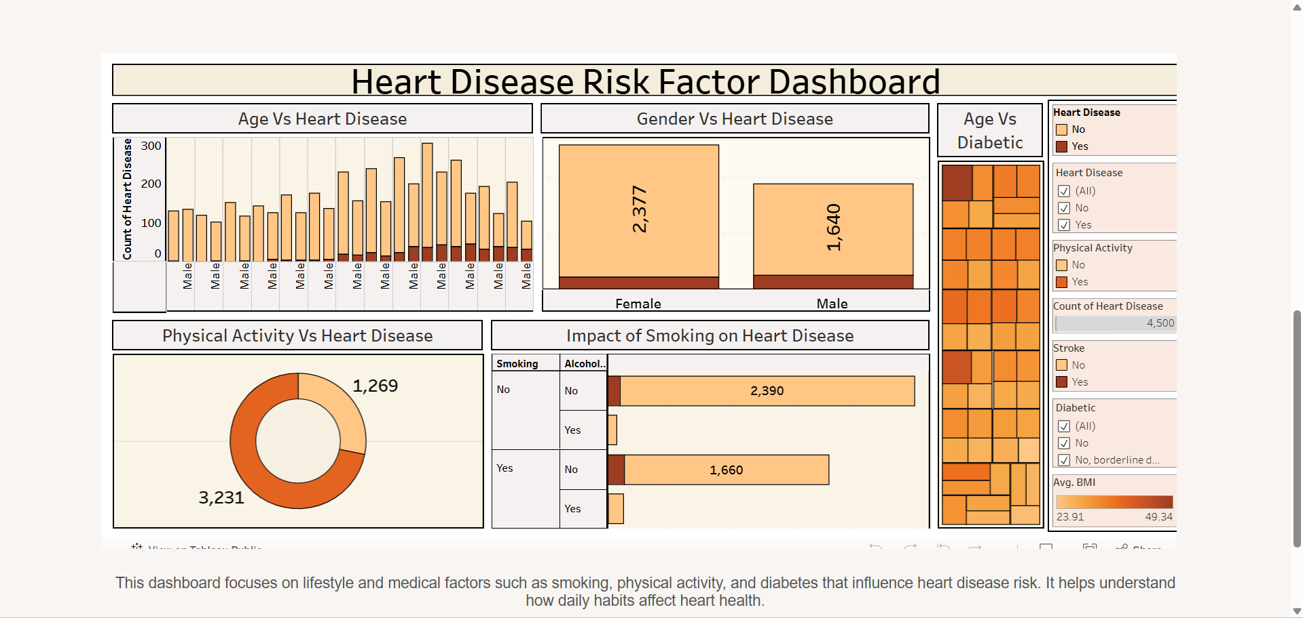

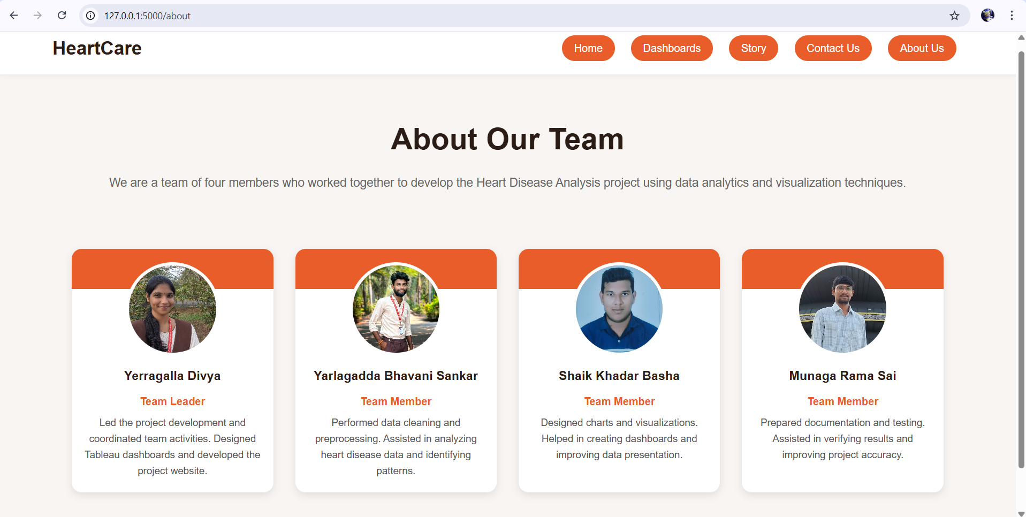

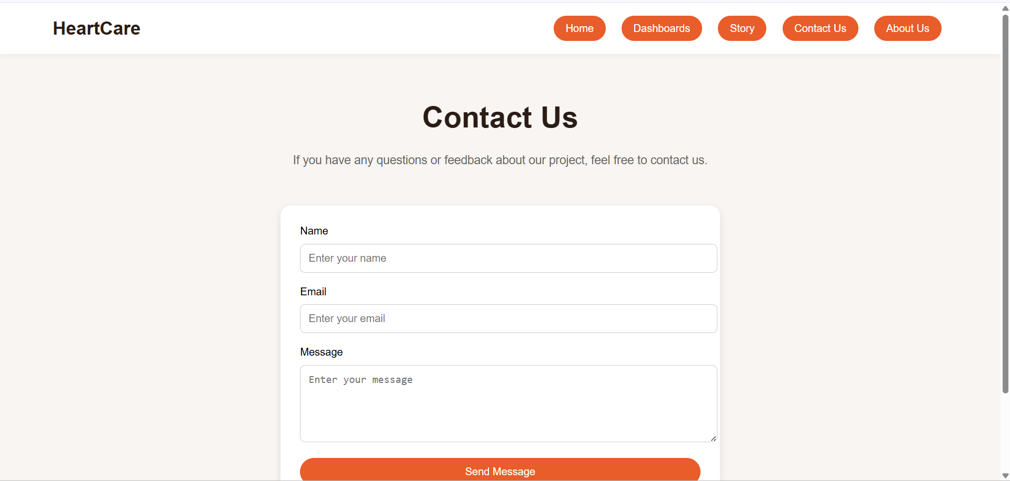

GitHub Repository Link : https://github.com/Divya-yerragalla/Heart-Disease-Analysis.git

Dataset Link : https://drive.google.com/file/d/190Qmq27LeZZ_nWricP3Obl7ys_5otEsp/view

Project Demo Video Link :
https://drive.google.com/file/d/1uZl2GPNmn9vkBQj3JzUYb0Zuen56ex9b/view?usp=sharing

